Narration:  Welcome to the world of competitive sports, where athletes pour their hearts and souls into the game they love. For years upon years, they hone their craft, and the game becomes their identity. But what happens when the final whistle blows, and the applause fades away?  Motion:  Fade from black, stock footage of a stadium.  Music:  Melancholy music fades in near the end of this scene. | 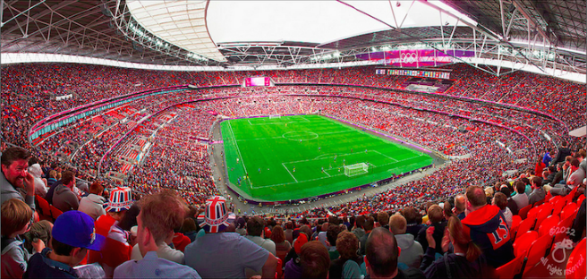
Narration:  For many athletes, the glory days are unforgettable. Moments etched in memory where their hard work and dedication pay off in the form of victory. These triumphs shape their identity, reinforcing the belief that they are defined by their athletic prowess and achievements on the field.  Motion:  Slow zoom  Music:  Continues | Intercut pictures of my team photos winning various championships throughout the years.
Narration:  But when the cheers fade and the spotlight dims, retired athletes often face a daunting transition. Stripped of their familiar roles and routines, they confront a profound sense of loss—a loss of identity, purpose, and connection to the game that has defined them for so long.  Motion:  Still shot  Music:  Fades as scene ends | Shot from behind me sitting in a chair looking at an old jersey pensively, conveying the sense of introspection as I am confronted by reality.
Narration:  As someone who was involved in the highest level of competitive soccer, I have personally faced this issue. When this activity (that took up all of my spare time for years) ended suddenly on a Thursday afternoon, I struggled with figuring out who I was outside of sports.  Motion:  Still shot  Music:  None | Mockumentary interview style shot, sitting in a chair with a blank wall behind me. This allows me to establish ethos with the audience drawing on their familiarity with documentaries.
Narration:  In the words of Dr Deborah Saint-Phard from Colorado University Womens Sports Medicine, “if all of the sudden you can’t be an athlete, it sends you into a bit of an existential crisis in terms of, “Who am I, and what am I doing here?”  Motion:  Image fades in.  Music:  None | Cuts to a different angle of me with the headshot of Dr Saint-Phard appearing overlayed on my audio continuing.
Narration:  With the pervasive culture of “tough it out” and years of being conditioned to not show pain, this issue of the athletic identity crises is only exacerbated. It is an often overlooked issue that affects many people after leaving the sport they devoted their life to.  Motion:  None.  Music:  Contemplative music fades in. | Scene begins dark, opens to stock footage of injured players.
Narration:  Yet, amidst the uncertainty, there lies an opportunity for discovery. Retired athletes begin to explore new passions and interests, embracing the freedom to pursue paths they may have never considered before. From creative pursuits to community service, they embark on a journey of self-discovery and personal growth.  Motion:  Smooth transitions between clips.  Music:  Continues. | Footage of me exploring outdoor interests (skiing, cliff jumping).
Narration:  With newfound clarity and conviction, retired athletes begin to reclaim their sense of agency and empowerment. They embrace their new identities with open arms, pursuing careers, hobbies, and relationships that align with their values and aspirations. Armed with resilience and determination, they chart a course towards a brighter and more fulfilling future.  Motion:  Smooth transitions between clips.  Music:  Continues | My clips continue
Narration:  In the journey to rediscover themselves, retired athletes find that the end of one chapter marks the beginning of a beautiful new story. With courage, resilience, and the support of loved ones, they embrace life's new adventures with open hearts and eager minds. If you or someone you know is struggling with the transition from sports, reach out for support. Together, we can navigate this journey and discover the endless possibilities that await beyond the game.  Motion:  Fade to black  Music:  Fades out | Stock footage of laughing families spending time together (I cannot film this as I am not currently with the family). The final shot is ground level as I walk away from the camera on a turf field.  Sources are shown.

Sources

The Loss of Your Athletic Identity — Sidelined USA

Life After Sport: Mitigating the Athlete Identity Crisis | BU Sport & Performance Psychology Team

Athletes struggle to find purpose, identity after sports | Special Report | News | gazette.com

